**EXPERIMENT – 9**

**AIM :**

Write the queries to create the views and queries based on views.

**THEORY :**

In this experiment we will see the implementation of Views. A VIEW is a virtual table, through which a selective portion of the data from one or more tables can be seen. Views do not contain data of their own. They are used to restrict access to the database or to hide data complexity. A view is stored as a SELECT statement in the database. DML operations on a view like INSERT, UPDATE, DELETE affects the data in the original table upon which the view is based.

**SYNTAX:**

CREATE VIEW view_name AS

SELECT column1, column2, ...

FROM table_name

WHERE condition;

view_name is the name of the VIEW.

The SELECT statement is used to define the columns and rows that you want to display in the view.

**PROCEDURE :**

**GIVEN TABLES:**

1. 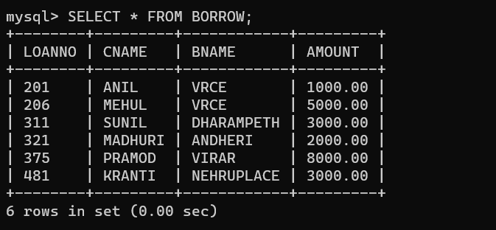**BORROW:**

**2. CUSTOMERS:**

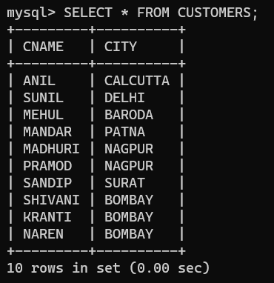

**3. BRANCH:**

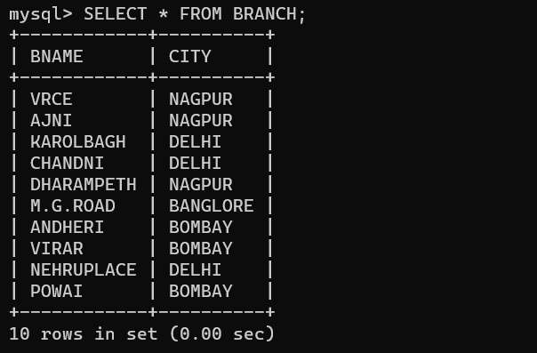

**4.DEPOSIT:**

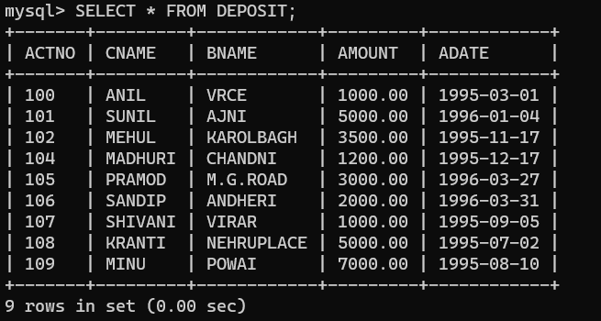

**QUERIES BASED ON VIEWS:**

**QUERY (i):** Create a view having CNAME, BNAME and AMOUNT.

**SYNTAX:** CREATE VIEW DEPOSITORS AS SELECT CNAME, BNAME, AMOUNT FROM DEPOSIT;

**OUTPUT:**

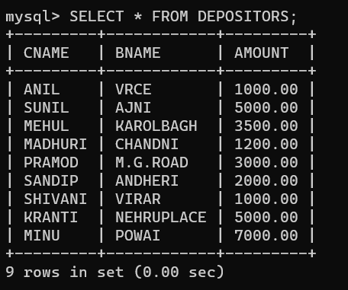

**QUERY (ii):** Add Rs.100 to the deposit of ANIL in the above created view.

**SYNTAX:** UPDATE DEPOSITORS SET AMOUNT = AMOUNT + 100 WHERE CNAME = 'ANIL';

**OUTPUT:**

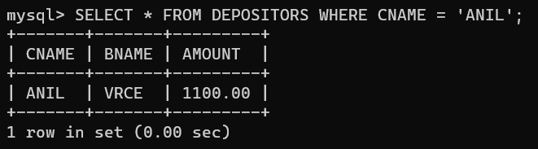

**QUERY (iii):** Delete the record of SUNIL from the above view.

**SYNTAX:** DELETE FROM DEPOSITORS WHERE CNAME = 'SUNIL';

**OUTPUT:**

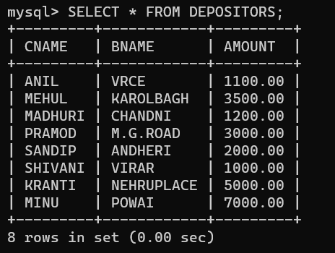

**QUERY (v):** Change LOAN NO of PRAMOD from 375 to 389.

**SYNTAX:** UPDATE LOAN SET LOANNO = 389 WHERE LOANNO = 375 from the above view;

**OUTPUT:**

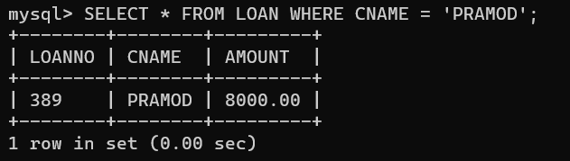

**QUERY (vi):** Delete record of borrower whose LOAN NO is 481 from the above view.

**SYNTAX:** DELETE FROM LOAN WHERE LOANNO = 481;

**OUTPUT:**

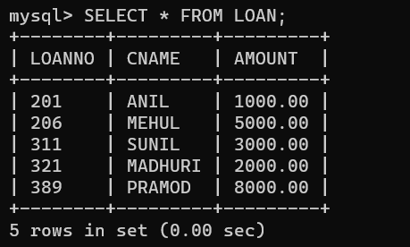

**QUERY (vii):** Give name of customers which are living in NAGPUR from the above view.

**OUTPUT:**

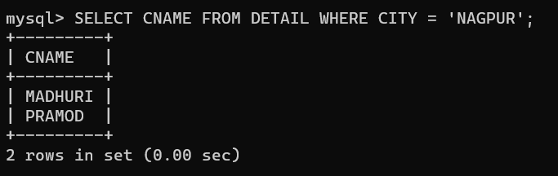

**QUERY (viii):** Create a view having ACTNO, CNAME, BNAME and CITY from DEPOSIT and CUSTOMERS. .

**SYNTAX:** CREATE VIEW DETAIL AS SELECT D.ACTNO, D.CNAME, D.BNAME, C.CITY FROM DEPOSIT D, CUSTOMERS C WHERE D.CNAME = C.CNAME;

**OUTPUT:**

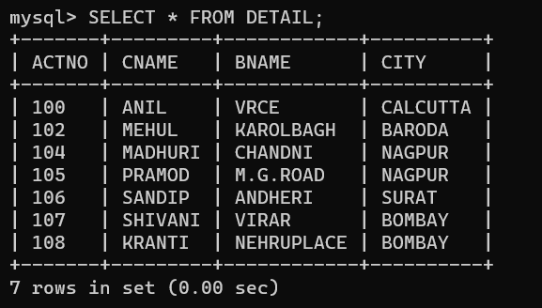

**QUERY (ix):** Update city of SANDIP from SURAT to DELHI in the above view.

**SYNTAX:** UPDATE DETAIL SET CITY = 'DELHI' WHERE CNAME = 'SANDIP';

**OUTPUT:**

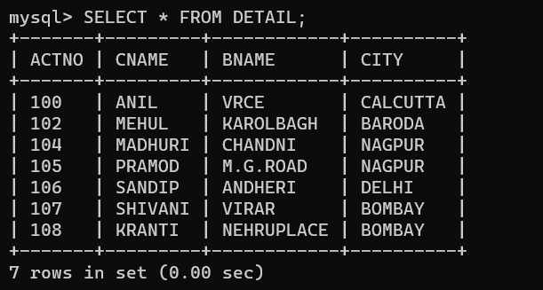

**QUERY (x) :** Give the number of customers living in a particular city from the above view;

**OUTPUT:**

